Linux Filesystem
How Linux organises, protects and finds your files
Date: 5 October 2026
Name: [Your Full Name]

1. Introduction to the Linux Filesystem
Anyone who moves from Windows to Linux notices the same thing within the first ten minutes: there is no C: drive. Everything lives under one single tree that starts at a forward slash, written as /. Documents, programs, settings, hard disks, USB sticks and even running processes all show up somewhere inside that tree. Once this idea clicks, the rest of Linux becomes much easier to read.

1.1 What is a filesystem?
A filesystem is the method an operating system uses to name, store, organise and retrieve data on a storage device. A raw disk is only a long run of blocks. The filesystem adds the structure on top: file names, folders, permissions, timestamps and a record of which blocks belong to which file. Without it, the disk would be unreadable to normal programs.
The word is used in two slightly different ways, and it helps to keep them apart. It can mean the on-disk format, such as ext4 or XFS, which decides how data is physically laid out on a partition. It can also mean the directory tree you see when you run ls /, which is the combined view of every mounted filesystem. This report talks about both.

1.2 A short history
The earliest versions of Linux in 1991 borrowed the Minix filesystem, which was limited to 64 MB partitions and short file names, so it ran out of room very quickly. The extended filesystem (ext) arrived in 1992, followed by ext2 in 1993, which became the workhorse for years. Journaling was added in ext3 (2001), and ext4 (2008) raised the size limits and improved speed. Other designs appeared along the way for different needs, including XFS, Btrfs, F2FS and ZFS ports. Today ext4 is still the default on many distributions, with XFS and Btrfs being common alternatives.

1.3 The Virtual File System layer
Linux can work with many different filesystems at the same time, and programs do not have to care which one they are touching. This works because of the Virtual File System (VFS), a layer inside the kernel that offers one common set of operations such as open, read, write and close. Each real filesystem plugs into the VFS with its own driver. A program that reads a file from an ext4 partition, a FAT32 pen drive or a network share uses exactly the same system calls.
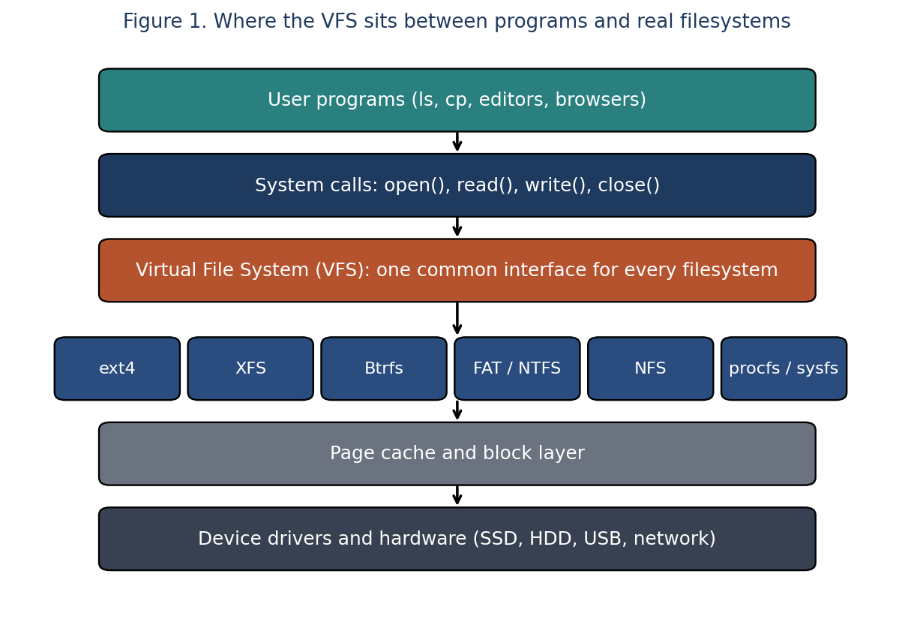
Figure 1. Where the VFS sits between programs and real filesystems
KEY HIGHLIGHT
The VFS is the reason a single command like cp can copy a file from an ext4 disk to an NTFS USB drive without knowing anything about either format.

2. Key Features of the Linux Filesystem

2.1 Features at a glance
- One unified tree: there are no drive letters. Extra disks are attached (mounted) at a folder inside the tree, for example /mnt/data or /media/user/USBDRIVE.
- Everything is a file: regular files, directories, hardware devices, sockets and even kernel information are exposed through the same file interface. You can read your CPU details with cat /proc/cpuinfo and talk to a disk through /dev/sda.
- Case sensitive names: Notes.txt, notes.txt and NOTES.TXT are three different files. This catches out many beginners.
- Permissions and ownership: every file has an owner, a group and a set of read, write and execute bits for owner, group and others. This is the base of Linux security.
- Inodes: each file is described by an inode that stores its metadata, while the directory entry only links a name to that inode.
- Links: hard links and symbolic links allow one file to be reached by more than one name or path.
- Journaling: filesystems such as ext4 and XFS keep a log of pending changes, so after a crash or power cut the system can recover quickly and with less risk of corruption.
- Support for many filesystem types: ext4, XFS, Btrfs, F2FS, FAT32, exFAT, NTFS, ISO 9660 and network filesystems such as NFS and SMB can all be mounted.
- Long file names and large files: names can be up to 255 bytes in most filesystems, and modern ones handle files in the terabyte range.
- Hidden files by convention: a name starting with a dot, like .bashrc, is hidden from a plain ls listing. There is no special hidden attribute.
- No required extensions: Linux decides how to treat a file from its permissions and content, not from the letters after the dot. A script can be called backup with no extension and still run.
- Advanced options: access control lists (ACLs), extended attributes, disk quotas, and on some filesystems snapshots, compression and checksums.

2.2 Popular Linux filesystem types
Type | Introduced | Strengths | Typical use
ext4 | 2008 | Stable, mature, good all round performance, journaling | Default for many desktop and server distributions
XFS | 1990s (SGI), in Linux since 2001 | Scales well with large files and parallel I/O | Servers, large storage and databases, default on Red Hat based systems
Btrfs | Merged into kernel in 2009 | Snapshots, checksums, built in compression, subvolumes | Systems that want easy rollback and flexible storage
F2FS | 2012 | Designed for flash memory | SSDs, eMMC and phones
tmpfs | Long standing | Lives in RAM, very fast, lost on reboot | /tmp, /run and other short lived data
FAT32 / exFAT | 1970s to 2000s | Readable on almost every device | USB sticks, SD cards, cameras
NTFS | 1993 (Windows) | Windows compatibility | Dual boot or external Windows disks
NFS / SMB | Network | Share files over a network | Shared team folders and home directories

The numbers vary between versions and settings, but as a rough guide ext4 supports single files in the terabyte range and volumes up to an exabyte, while XFS and Btrfs go higher still. For ordinary desktop and student use these limits are never reached.

2.3 Inodes, blocks and links
When you create a file, Linux needs to store two things: the data itself, kept in blocks on the disk, and the information about the data, kept in an inode. The inode records the size, owner, group, permissions, timestamps and the location of the data blocks. Notice that it does not record the file name. The name lives in the directory, which is really just a table mapping names to inode numbers.
This explains how links work. A hard link is another directory entry pointing to the same inode, so both names refer to exactly the same data and deleting one name does not delete the file until the last name is gone. A symbolic (soft) link is a small separate file that stores a path to another file, similar to a shortcut in Windows. If the target is deleted, the symbolic link is left pointing at nothing.
Point | Hard link | Symbolic link
Points to | The same inode (the data itself) | A path (the name of another file)
Works across filesystems | No | Yes
Can link to a directory | Not normally | Yes
If the original is deleted | Data stays, as long as one name remains | Link breaks
Create with | ln original link | ln -s original link

2.4 File types
The first character in the output of ls -l tells you what kind of file you are looking at.
Symbol | Type | Meaning and example
- | Regular file | Text, images, programs, anything ordinary. Example: report.txt
d | Directory | A folder that holds other entries. Example: /home
l | Symbolic link | A pointer to another path. Example: /bin on many modern systems
c | Character device | Hardware that moves data one character at a time, such as a terminal. Example: /dev/tty
b | Block device | Hardware that moves data in blocks, such as a disk. Example: /dev/sda
s | Socket | Used for communication between processes. Example: /run/systemd/private
p | Named pipe (FIFO) | A channel for passing data between processes

2.5 Permissions
Run ls -l and you will see something like -rwxr-xr-- on each line. The first character is the file type. The next nine characters are three groups of three, for the owner, the group and others. In each group, r means read, w means write and x means execute (or enter, in the case of a directory).
Octal | Symbolic | Meaning
7 | rwx | Read, write and execute
6 | rw- | Read and write
5 | r-x | Read and execute
4 | r-- | Read only
0 | --- | No access

So chmod 754 script.sh gives the owner rwx (7), the group r-x (5) and everyone else r-- (4). There are also three special bits. setuid lets a program run with the rights of its owner (the passwd command uses this). setgid does the same for the group, and on a directory makes new files inherit its group. The sticky bit on a directory, as seen on /tmp, stops users from deleting each other's files even if the directory is writable by all.
INSTANCE
Typing ls -ld /tmp prints drwxrwxrwt. The final t is the sticky bit. Everyone can create files in /tmp, but you can only remove the ones you own.

3. Directory Structure
Most Linux distributions follow the Filesystem Hierarchy Standard (FHS), a document that says which kind of file should live where. The current version is 3.0, published in 2015. Because of it, a program or an administrator can move between Ubuntu, Debian, Fedora or Arch and still know where to look for logs or configuration. Small differences remain between distributions, but the overall layout is the same.
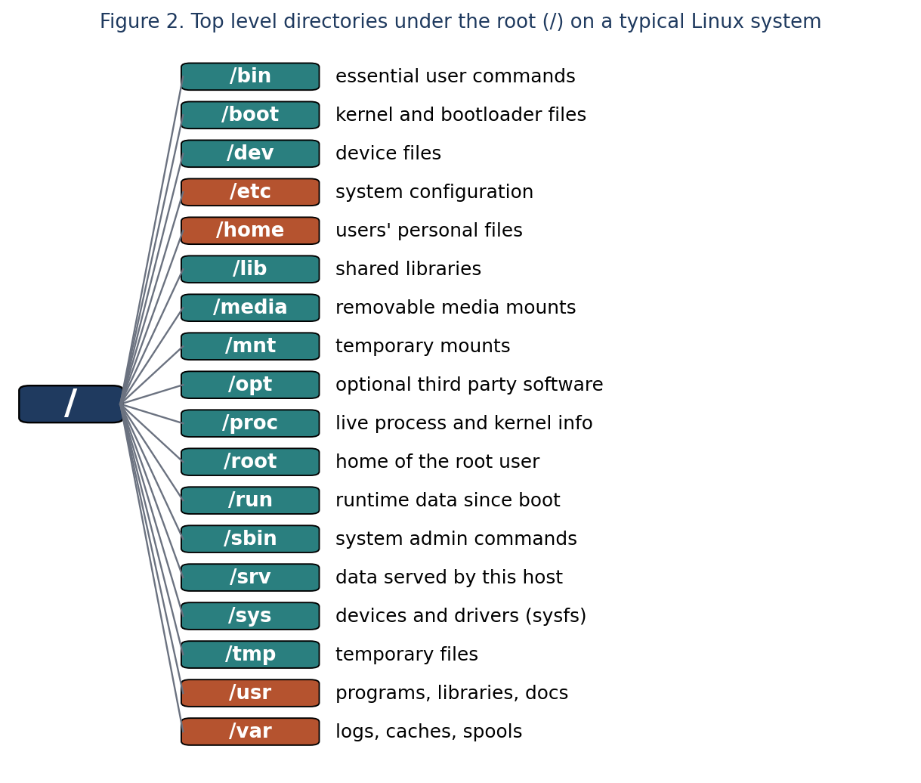
Figure 2. Top level directories under the root (/) on a typical Linux system

3.1 Absolute and relative paths
An absolute path starts at the root, for example /home/asha/notes.txt, and means the same thing no matter where you currently are. A relative path starts from your current directory, so if you are in /home/asha then notes.txt or ./notes.txt means the same file. A few symbols are useful to remember: a single dot (.) means the current directory, two dots (..) mean the parent directory, a tilde (~) means your home directory and a hyphen with cd (cd -) takes you back to the previous directory.

3.2 The main directories explained
Directory | Short name | What it holds
/ | Root | The top of the whole tree. Every other path starts here. Not to be confused with /root, which is a user's home folder
/bin | Binaries | Essential commands needed by everyone, such as ls, cp, cat and bash. On modern systems this is a symbolic link to /usr/bin
/sbin | System binaries | Commands for administration, such as fsck, reboot and ip. Often a link to /usr/sbin now
/boot | Boot files | The kernel image (vmlinuz), initial RAM disk and the bootloader files such as GRUB
/dev | Devices | Special files that represent hardware: /dev/sda for a disk, /dev/null that discards data, /dev/zero, /dev/random, /dev/tty
/etc | Configuration | System wide settings kept as plain text: user accounts, network, services, package sources
/home | Home folders | Personal folders for normal users, such as /home/asha, with their documents and hidden settings
/root | Root's home | The home directory of the administrator account, kept separate from /home
/lib, /lib64 | Libraries | Shared libraries needed by programs in /bin and /sbin, and kernel modules. Often links into /usr/lib
/media | Removable media | Automatic mount points for USB drives, DVDs and SD cards
/mnt | Mount | A place for temporary manual mounts by an administrator
/opt | Optional software | Self contained third party applications, for example Google Chrome or some vendor tools
/proc | Processes | A virtual filesystem showing live kernel and process information. Nothing here uses disk space
/sys | System | A virtual filesystem (sysfs) exposing devices, drivers and kernel settings
/run | Runtime | Data created since boot, such as process ID files and sockets. Cleared on reboot
/srv | Service data | Data served by this machine, for example web or FTP content
/tmp | Temporary | Short lived files that any user can create. Usually cleaned on reboot
/usr | Unix system resources | The bulk of installed software: programs, libraries and documentation. Mostly read only
/var | Variable data | Files that keep changing: logs, caches, mail, print queues and package databases
/lost+found | Recovered files | Fragments recovered by fsck on ext filesystems

3.3 Important subdirectories
Path | Purpose
/usr/bin | Most user programs, for example python3, gcc, vim
/usr/sbin | Administration programs that are not needed to boot
/usr/lib | Libraries used by programs in /usr/bin and /usr/sbin
/usr/local | Software installed by the local administrator, kept apart from the package manager
/usr/share | Architecture independent data such as manual pages, icons and documentation
/usr/include | C and C++ header files used when compiling programs
/usr/src | Source code, for example kernel sources
/var/log | System and application logs, such as syslog and auth.log
/var/cache | Cached data that can be rebuilt, for example downloaded package files
/var/lib | State information for programs, such as package databases
/var/spool | Queued jobs waiting to be processed: print, mail, cron
/var/tmp | Temporary files that should survive a reboot, unlike /tmp
/etc/passwd | Lists user accounts with their ID, home folder and shell (passwords are not stored here)
/etc/shadow | Holds the hashed passwords. Readable only by root
/etc/group | Group names and members
/etc/fstab | Tells the system which filesystems to mount at boot and where
/etc/hosts | Local name to IP address mappings
/etc/hostname | The name of this computer
/etc/resolv.conf | DNS server settings
/etc/sudoers | Defines who may use sudo
/etc/os-release | Name and version of the Linux distribution
/proc/cpuinfo, /proc/meminfo | Processor and memory details, read with cat
/dev/null | A black hole. Anything written to it disappears
~/.bashrc | Per user shell settings and aliases (the tilde is your home folder)

NOTE
On most current distributions the old split between /bin, /sbin, /lib and their /usr counterparts has been merged. /bin is now just a symbolic link to /usr/bin, and so on. You can check this on your own machine with ls -l /bin. Older books will still describe them as separate folders.

3.4 Mounting and fstab
A second disk or partition is not given a letter. It is mounted onto an existing empty folder called a mount point, and from then on its contents appear inside that folder. For example, mounting /dev/sdb1 on /mnt/data makes the files of that partition visible under /mnt/data. Unmounting detaches it again. To make a mount permanent across reboots, a line is added to /etc/fstab with six fields: the device, the mount point, the filesystem type, the options, a dump flag and the fsck order.
A typical fstab line reads: UUID=1234-abcd /home ext4 defaults 0 2. Using the UUID instead of a name like /dev/sdb1 is safer because device names can change between boots.

3.5 Typical partition layout
Many installers put everything in a single root partition, but some setups split the tree across partitions. A common arrangement is a small EFI or /boot partition, a root partition for / and a separate /home partition. Keeping /home apart means the operating system can be reinstalled without touching personal files. Servers often give /var its own partition as well, so that runaway logs cannot fill the disk that the system needs.

4. Basic Linux Commands
The commands below are grouped by purpose. Each one is shown with an example you can try in a terminal. Options (the parts starting with a hyphen) can usually be combined, so ls -l -a -h can be written as ls -lah. When you forget how a command works, type man followed by its name, or add --help after it.

4.1 Navigating and getting information
Command | What it does | Example
pwd | Prints the full path of the directory you are in (print working directory) | pwd
ls | Lists the contents of a directory. Useful options: -l long format, -a include hidden files, -h readable sizes, -R recursive, -t sort by time, -i show inode numbers | ls -lah /etc
cd | Changes directory. cd with no argument goes home, cd .. goes up one level, cd - jumps back to the previous directory | cd /var/log
tree | Draws a directory tree. The -L option limits the depth. It may need to be installed first | tree -L 2 /home
file | Tells you what kind of data a file contains, regardless of its name | file photo.jpg
stat | Shows detailed information: size, inode, permissions, owner and timestamps | stat notes.txt
which | Shows the full path of a command that would be run | which python3
whereis | Finds the binary, source and manual page for a command | whereis ls
realpath | Prints the absolute path of a file or link, resolving symbolic links | realpath ../notes.txt

4.2 Creating, copying, moving and deleting
Command | What it does | Example
touch | Creates an empty file, or updates the timestamp if the file exists | touch report.txt
mkdir | Creates a directory. The -p option also creates missing parent folders | mkdir -p projects/linux/labs
rmdir | Removes an empty directory | rmdir old_folder
cp | Copies files. -r copies directories, -i asks before overwriting, -v shows what is happening | cp -r labs labs_backup
mv | Moves a file or folder, and is also how you rename one | mv draft.txt final.txt
rm | Deletes files. -r removes directories and their contents, -i asks first, -f forces. There is no recycle bin, so deletions are permanent | rm -ri old_folder
ln | Creates a hard link. With -s it creates a symbolic link | ln -s /var/log/syslog ~/syslog-link
rename | Renames many files at once using a pattern (the exact syntax differs between distributions) | rename 's/.txt/.md/' *.txt

WARNING
Be careful with rm -rf, especially as root. A command such as rm -rf / or a typing slip like rm -rf ~ /tmp/x (note the space) can wipe out huge amounts of data without any confirmation. Check the path first, and use ls with the same path before deleting.

4.3 Viewing file contents
Command | What it does | Example
cat | Prints one or more files to the screen, and can join files together | cat part1.txt part2.txt > whole.txt
tac | Prints a file with the last line first | tac list.txt
less | Opens a file page by page. Use the arrow keys, / to search and q to quit | less /var/log/syslog
more | A simpler pager that only moves forward | more notes.txt
head | Shows the first lines of a file (10 by default). -n sets the number | head -n 5 notes.txt
tail | Shows the last lines. -f keeps watching and prints new lines as they are added, which is handy for logs | tail -f /var/log/syslog
wc | Counts lines, words and bytes. -l counts lines only | wc -l notes.txt
nl | Prints a file with line numbers | nl script.sh

4.4 Searching for files and text
Command | What it does | Example
find | Searches the directory tree in real time by name, type, size, owner or age | find /home -name "*.txt" -size +1M
locate | Searches a prebuilt database of file names, so it is very fast | locate passwd
updatedb | Refreshes the database used by locate | sudo updatedb
grep | Searches inside files for a pattern. -i ignores case, -r goes through folders, -n shows line numbers, -v shows lines that do not match | grep -rn "error" /var/log
egrep / grep -E | Searches with extended regular expressions | grep -E "fail|denied" auth.log
xargs | Builds a command from the output of another, useful together with find | find . -name "*.tmp" | xargs rm

4.5 Permissions and ownership
Command | What it does | Example
chmod | Changes permissions using numbers or letters. u is user, g is group, o is others, a is all | chmod 755 script.sh or chmod u+x script.sh
chown | Changes the owner and optionally the group of a file | sudo chown asha:dev report.txt
chgrp | Changes only the group | sudo chgrp dev report.txt
umask | Shows or sets the default permission mask for new files. A mask of 022 gives new files 644 and folders 755 | umask 022
id | Shows your user ID, group ID and the groups you belong to | id
whoami | Prints the name of the current user | whoami
sudo | Runs one command with administrator rights | sudo apt update
su | Switches to another user, by default root | su - ravi
chattr / lsattr | Sets or lists special attributes on ext filesystems, for example +i makes a file immutable | sudo chattr +i important.conf
setfacl / getfacl | Sets or reads access control lists for finer permission rules than owner, group and others | setfacl -m u:ravi:r report.txt

4.6 Redirection, pipes and wildcards
These are not commands themselves but symbols the shell understands. They are used constantly, and they are one of the biggest strengths of working in a terminal.
Symbol | Meaning | Example
> | Sends output to a file, replacing its contents | ls > files.txt
>> | Appends output to the end of a file | date >> log.txt
< | Feeds a file into a command as input | sort < names.txt
2> | Sends error messages to a file | find / -name x 2> errors.txt
| | Pipes the output of one command into another | ls -l | grep ".txt"
* | Wildcard for any number of characters | ls *.pdf
? | Wildcard for exactly one character | ls file?.txt
[ ] | Matches one character from a set | ls file[1-3].txt
&& | Runs the second command only if the first succeeds | mkdir test && cd test
; | Runs commands one after another | cd /tmp ; ls

Command | What it does | Example
tee | Writes output to the screen and to a file at the same time | ls -l | tee list.txt
sort | Sorts lines. -n sorts numerically, -r reverses | sort -n marks.txt
uniq | Removes repeated neighbouring lines. Usually used after sort. -c counts them | sort names.txt | uniq -c
cut | Extracts columns or fields from each line | cut -d: -f1 /etc/passwd
tr | Translates or deletes characters | echo hello | tr a-z A-Z
sed | Stream editor, commonly used for find and replace | sed 's/cat/dog/g' pets.txt
awk | Pattern scanning and reporting language, good for working with columns | awk '{print $1}' data.txt
diff | Shows the differences between two files | diff old.txt new.txt
echo | Prints text or the value of a variable | echo $HOME

4.7 Archiving and compression
Command | What it does | Example
tar | Bundles many files into one archive. c create, x extract, t list, z gzip, f file name, v verbose | tar -czvf backup.tar.gz projects/
tar (extract) | Unpacks an archive, with -C to choose the destination | tar -xzvf backup.tar.gz -C /tmp
gzip / gunzip | Compresses a single file, or reverses it | gzip bigfile.log
bzip2 / xz | Slower compressors that usually give smaller files | xz data.csv
zip / unzip | Creates and extracts zip files, which also open on Windows and macOS | zip -r project.zip project/

4.8 Disks and filesystems
Command | What it does | Example
df | Reports free and used space on each mounted filesystem. -h gives readable sizes | df -h
du | Reports how much space files and folders use. -s summarises and -h makes it readable | du -sh ~/Downloads
lsblk | Lists disks and partitions as a tree | lsblk
blkid | Prints the UUID and type of each block device | sudo blkid
findmnt | Shows mounted filesystems in a tree | findmnt
mount | Attaches a filesystem to a folder. With no arguments it lists current mounts | sudo mount /dev/sdb1 /mnt/data
umount | Detaches a mounted filesystem. Note the spelling, there is no letter n after the u | sudo umount /mnt/data
fdisk | Views and edits partition tables. Use -l to only list | sudo fdisk -l
mkfs | Creates a filesystem on a partition. This erases existing data on it | sudo mkfs.ext4 /dev/sdb1
fsck | Checks and repairs a filesystem. Run it on an unmounted partition | sudo fsck /dev/sdb1
sync | Forces cached data to be written to disk before you remove a device | sync

4.9 Users, processes and system information
Command | What it does | Example
useradd / adduser | Creates a new user account | sudo adduser ravi
passwd | Changes a user's password | passwd
usermod | Modifies an account, for example adding it to a group | sudo usermod -aG sudo ravi
groups | Lists the groups a user belongs to | groups ravi
userdel | Deletes a user account | sudo userdel ravi
ps | Lists running processes. ps aux shows all of them | ps aux | grep firefox
top / htop | Live view of processes and resource use | top
kill | Sends a signal to a process, usually to stop it | kill 2314
uname | Prints system information. -a shows everything | uname -a
uptime | Shows how long the system has been running | uptime
free | Shows memory use. -h gives readable sizes | free -h
date | Prints the date and time | date
history | Lists the commands you typed earlier | history | tail
alias | Creates a short name for a longer command | alias ll='ls -lah'
man | Opens the manual page of a command | man chmod
clear | Clears the terminal screen | clear

4.10 A worked example
The sequence below ties several commands together. It makes a small project folder, writes a file, copies it, links it, locks down the permissions and then checks the result. You can follow it on any Linux machine or in a virtual machine.
Step | Command | What happens
1 | cd ~ | Moves to your home directory
2 | mkdir -p lab/docs | Creates lab and, inside it, docs in one go
3 | cd lab/docs | Moves into the new folder
4 | echo "first note" > note.txt | Creates note.txt containing one line
5 | cp note.txt note_backup.txt | Makes a copy
6 | ln -s note.txt shortcut | Creates a symbolic link named shortcut
7 | chmod 640 note.txt | Owner can read and write, group can read, others get nothing
8 | ls -l | Lists the files and shows the permissions and the link arrow
9 | grep "note" note.txt | Finds the word inside the file
10 | cd ~ && tar -czf lab.tar.gz lab | Packs the whole folder into a compressed archive
11 | du -sh lab.tar.gz | Shows how big the archive is
12 | rm -r lab | Removes the original folder, leaving only the archive

5. Good Habits when Working with Linux Files
- Use tab completion. Pressing the Tab key finishes names for you and prevents typing mistakes.
- Keep personal work under your home folder and avoid changing things in /etc or /usr unless you know why.
- Make a backup before bulk operations, and run ls on a pattern before using it with rm.
- Do not work as root for everyday tasks. Use sudo only for the single command that needs it.
- Quote file names that contain spaces, for example cd "My Notes", or avoid spaces completely.
- Check free space with df -h before large downloads or installs, and clear caches in /var/cache if disks fill up.

Review Questions
The questions below come from the earlier topics in this series (sensors, Git and robotics). Each answer is followed by the sources used to check it, so the claims can be verified. Where a question depends on a loose definition, the answer says so.

Q1. What is the difference between a 6 DoF and a 9 DoF IMU?
DoF stands for degrees of freedom, which here simply counts the independent measurement axes inside the sensor. A 6 DoF IMU has a 3 axis accelerometer and a 3 axis gyroscope. A 9 DoF IMU is the same thing plus a 3 axis magnetometer. The extra three axes matter mainly for heading.
 | 6 DoF IMU | 9 DoF IMU
Sensors | Accelerometer (3) + gyroscope (3) | Accelerometer (3) + gyroscope (3) + magnetometer (3)
Gives | Pitch and roll from gravity, plus rotation rates | Everything on the left plus a compass style heading
Yaw (heading) | Relative only, drifts slowly over time | Can be corrected against the Earth's magnetic field
Weakness | Yaw drift | Magnetometer is disturbed by motors, steel and magnets and needs calibration
Typical chips | MPU6050 | MPU9250 (also BNO055, ICM20948)

A small caution: one source points out that, strictly, a magnetometer is not an inertial sensor, so a so called 9 DoF IMU is technically a 6 DoF IMU with a separate 3 DoF digital compass. In practice the name 9 DoF is used everywhere on product pages.
PROOF
MPU6050 vs MPU9250 comparison (Zbotic): zbotic.in/mpu9250-vs-mpu6050-9-dof-vs-6-dof-imu-comparison, which lists 3 axis accelerometer and gyroscope for 6 DoF and states the 9 DoF adds a magnetometer for absolute yaw and drift correction.
Best Performance Group, Inertial Sensor Motion Tracking: bestperformancegroup.com/?page_id=34, for the point about magnetometers not being inertial sensors.

Q2. What are the 3 degrees of freedom with respect to the magnetic component of an IMU?
The magnetic component is the magnetometer, and its three degrees of freedom are its three measurement axes, X, Y and Z. It measures the strength of the magnetic field along each of those body axes, usually written Bx, By and Bz and reported in microtesla or gauss. Together they form a vector that points along the Earth's magnetic field. Once the sensor is level (or tilt corrected using the accelerometer), the horizontal part of this vector gives magnetic north, and from that the heading angle (yaw).
PROOF
Zbotic comparison page lists the 3 DoF magnetometer as measuring the Earth's magnetic field vector, and explains that adding it gives absolute yaw: zbotic.in/mpu9250-vs-mpu6050-9-dof-vs-6-dof-imu-comparison.
The sensor motion tracking article also describes the 3 axis magnetometer as a digital compass: bestperformancegroup.com/?page_id=34.

Note: the third line in the list you were given, "Add another section to the report regarding review questions", is an instruction and not a question, so it has not been answered here. This section is that addition.

Q3. Encoder vs IMU: which is better for use on the arm?
For measuring the angle of a joint, the encoder is the better and more standard choice. It sits right on the joint (or motor shaft), reads the angle directly, and does not accumulate drift. An IMU only gives orientation of whatever link it is attached to, and it has to work that out by combining noisy sensors. A 6 axis IMU in particular cannot measure yaw without drift, which one research team had to work around by taking the first joint angle from the encoder instead.
The IMU is better in a different role. It tells you how a link is actually oriented in space and how it is accelerating, which an encoder cannot do. That helps with detecting link flex or deflection, tilt of the end effector, vibration and shaking, and it can act as a cheap backup. One IEEE study estimated joint angles on a PR2 arm using low cost accelerometers and a gyroscope and compared them with the optical encoders, reaching a mean error of about 1.3 degrees. The authors suggest it can serve as an alternative in cheap manipulators and as redundant measurements for safety in others.
 | Encoder | IMU
Measures | Joint angle (and speed) directly | Orientation, rotation rate and acceleration of a link
Drift | None for absolute encoders | Gyroscope drift, accelerometer noise
Accuracy for joint position | High | Lower, depends on filtering and calibration
Sees link bending or backlash | Not at the link end | Yes, since it rides on the link
Needs calibration | Zeroing at startup (or none if absolute) | Regular calibration and sensor fusion
Best use on an arm | Joint position control | Link motion, tilt, vibration, redundancy

Answer in one line: use encoders for joint control, and add an IMU where you care about the link or end effector in space. The best systems fuse both.
PROOF
Online Estimation of Self-Body Deflection (arXiv 2306.03616): arxiv.org/pdf/2306.03616. It uses encoder values for the first joint because a 6 axis IMU cannot measure yaw without drift.
Inertial Sensor-Based Humanoid Joint State Estimation, Rotella et al. (arXiv 1602.05134): arxiv.org/pdf/1602.05134. It notes joint position is traditionally measured by angular sensors and discusses fusing IMU data with encoder measurements.
IEEE paper abstract on low cost joint angle estimation with accelerometers and a gyroscope on a PR2 arm (1.3 degree mean error): infona.pl/resource/bwmeta1.element.ieee-art-000006385893.

Q4. Why is a stereo camera digital?
The honest answer is that a stereo camera does not have to be digital in principle, but in practice it always is. The idea of stereo is just geometry: two cameras placed a known distance apart see the same object at slightly different positions, and that shift, called disparity, depends on how far away the object is. Old stereoscopic photographs on film used the same principle for human viewing.
What makes a stereo camera for robots and computers digital is the next step. To get depth, software must find matching points in the left and right images and measure their shift, then calculate depth with the formula depth = focal length x baseline / disparity. This matching works on a grid of pixel values, needs the two cameras to be calibrated very accurately, and is heavy computation, so it is done by a processor. Image sensors such as CMOS and CCD chips convert light into numbers, which makes the output ready for that processing and for storage and networking. An analog video signal would first have to be digitised anyway, adding noise and delay.
PROOF
Wikipedia, Computer stereo vision: en.wikipedia.org/wiki/Computer_stereo_vision. Defines it as extracting 3D information from digital images and explains disparity maps.
Basler documentation, Stereo Camera Technology: docs.baslerweb.com/stereo-camera-technology. Explains disparity, stereo matching (Semi-Global Matching) and the need for precise calibration.
National Instruments, 3D imaging with Vision Development Module: ni.com (page titled 3D imaging with NI LabVIEW). Gives depth = f x b / disparity.

Q5. Where would you use an analog camera vs a digital camera?
An analog camera sends its picture as a continuous video signal (for example PAL or NTSC) down a cable or radio link. A digital camera converts the picture to data, which can be compressed, sent over a network and processed by a computer. Note that most modern analog cameras still have a digital sensor inside. The word analog mostly describes the output signal.
 | Use an analog camera when | Use a digital camera when
Latency | Delay must be as small as possible, such as racing or fast FPV flying, where analog systems are reported around 2 to 5 ms against 20 to 50 ms for digital | A small extra delay is acceptable
Cost and simplicity | You need cheap, simple, plug and play parts with no network setup | You can afford more complex hardware
Existing setup | You are reusing old coaxial CCTV cabling or analog goggles and monitors | You are building a new system
Image quality | Quality is not the priority | You need high resolution, clear detail, low noise
Processing | You only need a live picture for a human to watch | A computer must analyse the picture: robot vision, stereo depth, object detection, recording and search
Network and security | One viewer on a dedicated link is enough | Several streams, encryption, remote access over IP
Examples | Hobby FPV racing drones, simple legacy CCTV | Mars rover cameras, stereo vision, IP surveillance with analytics, smartphones

One academic study that measured delay in surveillance systems found analog cameras do have lower latency, but most IP (digital) cameras were still within acceptable limits. So the old complaint about digital delay matters only in the most time critical uses.
PROOF
Doodle Labs, Analog vs Digital Drone Comms: doodlelabs.com/blog/analog-vs-digital-drone-comms-in-the-autonomy-era/. Analog is a direct low overhead path, while digital adds encryption, multiple streams and IP integration.
Zbotic, Best FPV Cameras 2026: zbotic.in/best-fpv-cameras-2026-analog-vs-digital-compared/. Source of the 2 to 5 ms versus 20 to 50 ms figures (a retailer guide, so treat the numbers as typical rather than exact) and the note that modern analog cameras use CMOS sensors.
Hill et al., Measuring latency for video surveillance systems, DICTA 2009: digital.library.adelaide.edu.au/items/0977947f-c592-42e1-98fe-bd84b993966f.

Q6. git reset vs git revert?
Both undo changes, but in different ways. git reset moves the branch pointer back to an earlier commit, so the later commits disappear from the branch history. With --soft your changes stay staged, with the default mixed mode they stay in the working folder, and with --hard they are thrown away. git revert leaves history alone and adds a new commit that applies the opposite of an earlier commit, so the original stays in the log and the undo is recorded.
 | git reset | git revert
What it does | Moves the branch pointer back | Creates a new commit that cancels an earlier one
Effect on history | Rewrites it, commits are removed from the branch | Preserves it, adds one more commit
Safe on shared branches | No, others will have conflicts and a force push is needed | Yes
Best for | Local commits not yet pushed | Commits already pushed, or when you want an audit trail
Example | git reset --soft HEAD~1 | git revert a1b2c3d

Check it yourself: make two test commits, run git log --oneline, then run git reset --hard HEAD~1 and look at the log again (one commit is gone). Repeat with git revert HEAD and you will see an extra commit named Revert followed by the original message.
PROOF
DeployHQ, What is the difference between git reset and git revert: deployhq.com/git/faqs/difference-git-reset-revert.
GitLab help page on rolling back commits (git reset removes the commit, git revert undoes the changes but keeps the commit): gitlab.ufpe.br/help/topics/git/rollback_commits.md.

Q7. git pull vs git fetch?
git fetch downloads new commits from the remote and updates your remote tracking branches such as origin/main, but it never touches your current branch or working files, so it cannot cause conflicts. git pull does the same fetch and then immediately merges the fetched commits into the branch you are on. In short, git pull is git fetch plus git merge (or a rebase if you use git pull --rebase). Fetching first lets you inspect what changed, for example with git diff main origin/main, before you decide to merge.
 | git fetch | git pull
Downloads remote commits | Yes | Yes
Changes your current branch | No | Yes, merges them in
Can cause merge conflicts | No | Yes
Equivalent to | Only the download step | git fetch followed by git merge
Example | git fetch origin | git pull origin main

PROOF
Linuxize, git fetch vs git pull: linuxize.com/post/git-fetch-vs-git-pull/.
GoLinuxCloud, git fetch vs git pull explained: golinuxcloud.com/git-fetch-vs-git-pull-examples/.
DeployHQ, difference between git fetch and git pull: deployhq.com/git/faqs/difference-between-git-fetch-and-git-pull.

Q8. How many commands are there in git config?
The question needs a small correction, because git config is a single command, not a group of separate commands. What can be counted are its subcommands (or, in older versions, its options). In recent Git versions, the manual page for git config lists seven subcommands: list, get, set, unset, rename-section, remove-section and edit. There is also an extra form, git config --get-colorbool, listed alongside them in the synopsis.
Subcommand | Purpose
list | Show every configuration variable and its value
get | Show the value of one setting
set | Set the value of a setting
unset | Remove a setting
rename-section | Rename a section of the config file
remove-section | Delete a whole section from the config file
edit | Open the config file in your editor

Older Git versions, which most tutorials still use, do the same jobs with options on the same command, for example git config --list, git config --get user.name, git config --unset user.name and git config --edit. The manual page maps each of these old forms to the new subcommand. Separately, the number of individual configuration variables (like user.name or core.editor) is much larger and can be listed with git help --config.
Check it yourself: run git --version, then git config --help, and compare the synopsis with the list above. If your Git is older, the subcommand names will not appear and you will see the option forms instead.
PROOF
Official Git documentation for git-config: git-scm.com/docs/git-config.
Ubuntu manual page for Git 2.48.1, showing the same synopsis: manpages.ubuntu.com/manpages/plucky/man1/git-config.1.html.
man7.org Linux manual page, which lists the old options replaced by the subcommands: man7.org/linux/man-pages/man1/git-config.1.html.

Conclusion
The Linux filesystem looks strange at first because it breaks the drive letter habit, but it follows a few simple ideas: one tree starting at /, everything treated as a file, strict permissions, and a standard layout that every distribution respects. Understanding what lives in /etc, /home, /var and /usr, and knowing how to move around with ls, cd, find, grep and chmod, already covers most of what a beginner needs. The rest comes from practice in a real terminal, ideally in a virtual machine where mistakes cost nothing.

References and Further Reading
- Filesystem Hierarchy Standard 3.0, Linux Foundation, 2015 (copy at debian.org/doc/packaging-manuals/fhs/fhs-3.0.txt).
- Linux manual pages: hier(7), file-hierarchy(7), ext4(5), mount(8), chmod(1), find(1). Read them with the man command.
- W. Shotts, The Linux Command Line, No Starch Press (free online at linuxcommand.org).
- M. Kerrisk, The Linux Programming Interface, No Starch Press, chapters on file systems and file I/O.
- Sources listed under each review question above.

